COMPETITION BRIEF

COMPETITION FOR THE CONCEPTUAL DESIGNOF THE REVITALIZATION AND DEVELOPMENT OF THE ZLATICA PARK-FORESTIN PODGORICA

Capital City of Podgorica
Njegoševa St., No. 13, Podgorica
Montenegro
www.podgorica.me

CONTENTS:

1. INTRODUCTION 3
2. SUBJECT AND OBJECTIVE OF THE COMPETITION 3
3. GENERAL CHARACTERISTICS OF THE AREA 4
3.1. Data from spatial and planning documentation 7
3.2. Existing condition of the area 7
3.3. Familiarization with local natural conditions 9
3.4. Traffic characteristics of the area 10
4. COMPETITION BRIEF 11
4.1. General guidelines 11
4.2. Specific program conditions, conclusions and recommendations 13
4.2.1. Conditions for conducting the competition 14
4.2.2. Regulations and recommendations for design 14

INTRODUCTION

The Mayor of the Capital City of Podgorica issued a Decision on announcing the competition for the conceptual design of the revitalization and development of the Zlatica Park-Forest in Podgorica No. 01-018/25-5792 of 8 September 2025.
The legal basis for the adoption of the Decision is contained in the provisions of Article 15, paragraphs 1 and 4 of the Law on Construction of Structures ("Official Gazette of Montenegro", No. 19/25), Article 6 of the Rulebook on the manner and procedure for announcing and conducting a public competition for a conceptual architectural design ("Official Gazette of Montenegro", Nos. 19/18, 2/24 and 8/24), as well as Article 100, paragraph 1, item 20 of the Statute of the Capital City ("Official Gazette of Montenegro –consolidated text", Nos. 8/19, 20/21 and 49/22).
The competition for a conceptual design is announced and conducted in accordance with the Rulebook on the manner and procedure for announcing and conducting a public competition for a conceptual architectural design ("Official Gazette of Montenegro", Nos. 19/18, 2/24 and 8/24).
The subject site is located within the scope of the current Spatial Urban Plan of the Capital City of Podgorica ("Official Gazette of Montenegro –consolidated text", No. 3/14).

The Mayor of the Capital City of Podgorica issued a Decision on determining the location with elements of urban and technical conditions for the construction of a local structure of public interest – revitalization and development of the Zlatica Park-Forest on a part of cadastral parcel No. 4608/1, Cadastral Municipality Podgorica II, in Podgorica No 01-018/25-5774 of 8 September 2025.

The subject competition results from the need to obtain, through innovative landscape and architectural designs, a vision of the transformation ofthe unused space in the Zlatica Park-Forest, as an important part of the green infrastructure of the Capital City, which represents the basis for improving the quality of life of all residents of Podgorica, adapting to climate change, and establishing ecological stability.

The Spatial and Urban Plan of the Capital City of Podgoricauntil 2025, defines sustainable urban development, biodiversity protection, and mitigation of climate change impacts among the main long-term goals of spatial development. Negative phenomena in space relate to the formation of urban agglomerations, degradation of the cultural landscape and the environment, as well as heat extremes during summer months, which affect the quality of life of the city's residents and its overall socio-economic development.

SUBJECT AND OBJECTIVE OF THE COMPETITION

The subject and objective of the competition is to obtain the best conceptual landscape and architectural design for the revitalization and development of the Zlatica Park-Forest, which will serve as the basis for further development of the main project.

The competition entries are expected to deliver:
- Identity and Program of the Park-Forest– A functional solution for the planned program elements with strong design qualities intended for the rest and recreation of citizens. A space should be designed for various activities and events throughout the year –a multifunctional recreational park area with facilities such as an area for rest and outdoor recreation, children's play, sports and recreation, culture/education. The park program should be attractive, inclusive and accessible to all user groups;
- Emphasis on the ecological aspect – the focus is on a design approach that focuses on nature-based solutions, ensuring that the future Park-Forestpromotes biodiversity and improves the stability of the ecosystem. In designing the park, priority should be given to the restoration and establishment of local flora and fauna, contributing to the preservation of nature and improvement of quality of life in the city;
- Community engagement – ​​support the involvement of the local communityand social cohesion through inclusive design, which is responsive to different user groups, regardless of origin, status or age. Provide for the facilities that enable educational and cultural events and promote environmental awareness, contributing to the creation of a positive image of this part of the city as a desirable place to live.

The participants are expected to present a vision of transforming the subject area into a natural oasis, which reflects a contemporary landscape-architectural approach, with the aim of restoring natural and ecological harmony in the urban environment, and adapting to climate change.
The development of the Zlatica Park-Forest aims to establish an integrated Greenery System of Podgorica and strengthen the city's green infrastructure.

GENERAL CHARACTERISTICS OF THE AREA

The boundary of the intervention area is given on the topographicsurvey map in the competition material. The intervention area is 346,080m² (34.60 ha), located on the southern edge of the Podgorica settlement of Zlatica, owned by the Capital City and includes a part of the cadastral plot No. 4608/1 CM Podgorica II, which is defined by the coordinates specified in the Decision on determining the location with elements of urban and technical conditions for the construction of a local structure of general interest - revitalization and development of the Zlatica Park-Forest on a part of cadastral plot No. 4608/1 CM Podgorica II in Podgorica:
The site is accessed from Branko Ćopić Street, the vehicular access is asphalted up to the existing basketball court, which also has an asphalt surface. Part of the subject area is covered with gravel and serves as a parking lot for visitors' vehicles. The existing structures on the site include a cafe bar with an outdoor seating area and a covered five-a-side football field with artificial grass as the surface. Near the cafe bar, there is a children's playground placed directly on anearthen surface. At the southern end of the site, there is an improvised exercise area with several pieces of equipment. The participants in the competition are not obliged to preserve the existing temporary structures in the park. The subject site is a mixed forest of Aleppo pine (Pinus halepensis) and cypress (Cupressus sempervirens).In a part of the site, the consequences of devastation of the green stock are evident, and the attempts have recently been made to mitigate them through the planting of new trees. The park is currently enclosed by a fence that is in a relatively good condition (possibly partial repairs or repainting are required). The park can be accessed from several pedestrian and several pedestrian-vehicularentrances/gates. From Nikola Tesla Street, one pedestrian and vehicularentrance is provided, which leads to the Zagorič water source. From the western green area, along the busy boulevard, it is possible to access the park from two pedestrian entrances, from Branko Ćopić Street there is an existing asphalted vehicular entrance, but there is also an alternative access to the park. The boundary of the Zagorič water source, along with its protected surroundings, is excluded from the intervention area.Between Vili Brant Boulevard and the border fence there is a fire protection zone (17-24m wide), but also an area where water installations are laid that serve the water supply needs for a large part of ​​the settlement in the surrounding area. In this regard, there are no planned interventions involving facilities in this intervention area, but it needs to be landscapedat ground level and connected to the park itself. It is necessary to plan parking areas within this stretch, and the possibility of planting tall vegetation with deep roots is excluded.
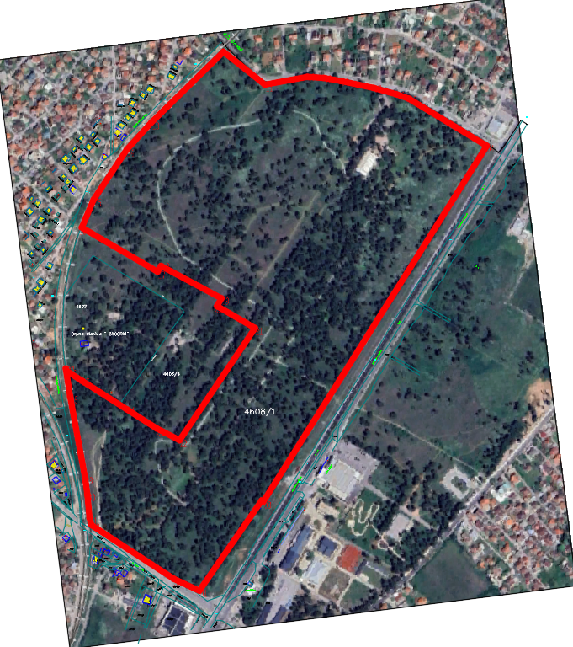

View of the intervention area of the Zlatica Park-Forest
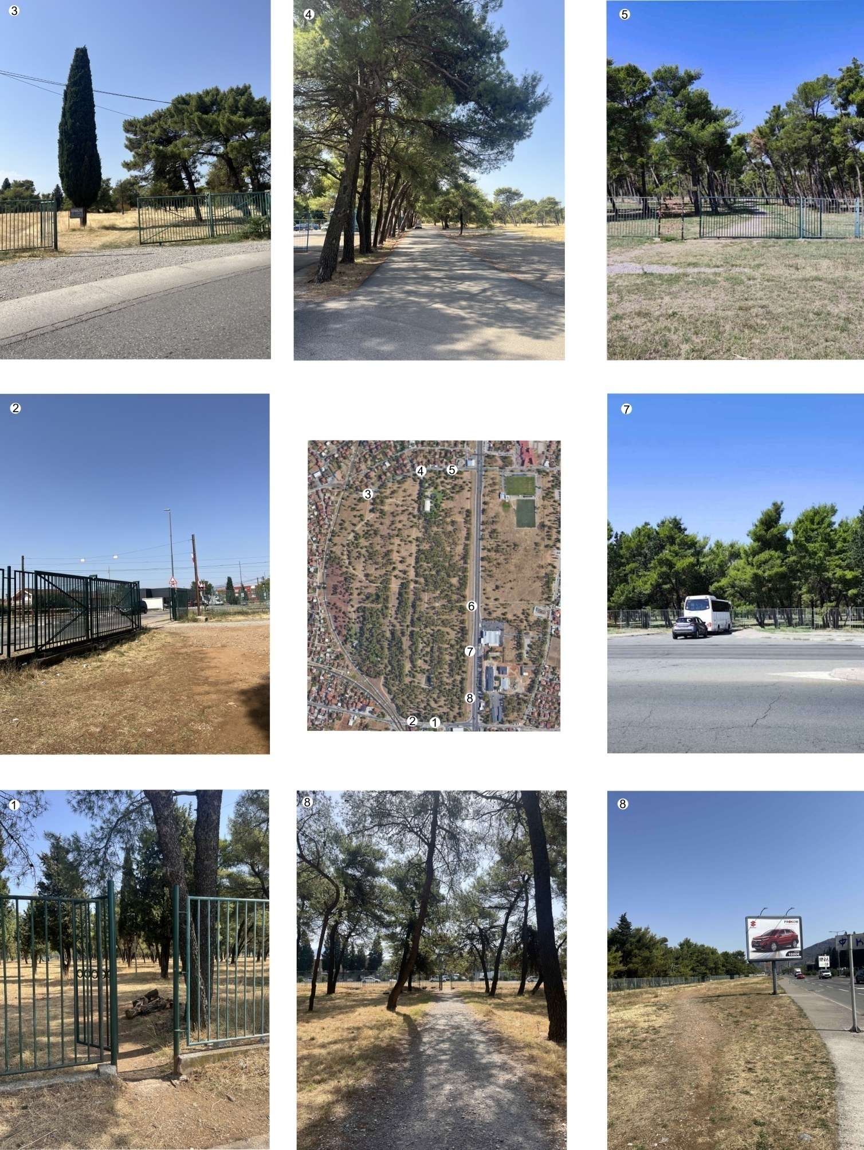

View of the main entrances to the park

1. Pedestrian entrance from Nikola Tesla Street
2. Vehicular entrances from Nikola Tesla Street towards the Zagorič water source
3. Vehicular entrances from Branko Ćopić Street
4. Currently the main Vehicular entrance to the park from Branko Ćopić Street
5. A frequently used entrance, but not an official entrance
6. Pedestrian entrances from Vili Brant Boulevard
7. Fire service entrance from Vili Brant Boulevard
8. Pedestrian entrances from Vili Brant Boulevard

Data from spatialandplanning documentation

The subject site is located within the SUP of the Capital City of Podgorica ("Official Gazette of Montenegro –consolidated text" No. 3/14). According to the graphic annex "General Urban Design - detailed category land use plan", the subject site is designated as a "public landscape design (PLD)". In the graphic annex "GUD Podgorica - green space development plan", the site is more specifically designated as a "park-forest".
The legal basis for announcing the competition is the Decision on determining the location with elements of urban and technical conditions for the construction of a local structure of general interest - revitalization and development of the Zlatica Park-Forest on a part of cadastral parcel No. 4608/1 CM Podgorica II in Podgorica No 01-018/25-5774 of 8 September 2025, which is an integral part of the competition documentation.

Existing condition of the area
Thesite of approximately 35 ha,where the Zlatica Park-Forest is located lies northeast of the city, along the busy Vili Brant Boulevard, which leads to suburban settlements but also to the highway to the north of Montenegro, serving as one of the main exits/entrances to the City of Podgorica. The park, which is located in a very densely built residential areas dominated by individual family housing, is bordered on the north by Branko Ćopić Street, on the south by Nikola Tesla Street, on the east by the railway line and on the west by the existing protective fence, towards Vili Brant Boulevard. In fact, the intervention area of the Zlatica Park-Forest revitalization and development covers the area bordered by the existing protective fence of the park, excluding the Zagorič water source, whose protection zone is given in the graphic annexes.
On a macro level, on the southern side, there is another park-forest that has been declared a natural monument, the Gorica Park-Forest, and south of Gorica is the city centre of Podgorica.
On a micro level, the site itself is surrounded by the following structures and facilities: the Zlatica Health Centre, "Dragiša Ivanović" Elementary School, the football stadium with auxiliarytraining fields of the "Kom" Football Club, hypermarket, the Training Centre of the Special Police Unit and specialized police unit, a gas station and a settlement with individual housing units, separated by a railway line.
The site that is the subject of the competition is predominantly flat, with a large proportion of tall vegetation. The existing tree stock consists mostly of Aleppo pine trees with a smaller proportion of cypress trees. Originally, the entire area was established as an urban windbreak belt, so in the period after the Second World War, these species were planted as pioneer species with low requirements for land and climate conditions. The aim was improving the microclimatic conditions and enabling the later planting of other species, and the already established pine forest would represent a type of protection for new trees. Despite periodic attempts to supplement it with deciduous species, due to a lack of maintenance and the absence of an irrigation system, those treese did not survive in the subject area.
The site is not too far from the city centre and has good connection with road traffic. Moreover, the intervention area is not located within the traditionally-inherited urban context, and in this regard, the design of an innovative zone is permitted, which must respect the existing infrastructural and landscape conditions.

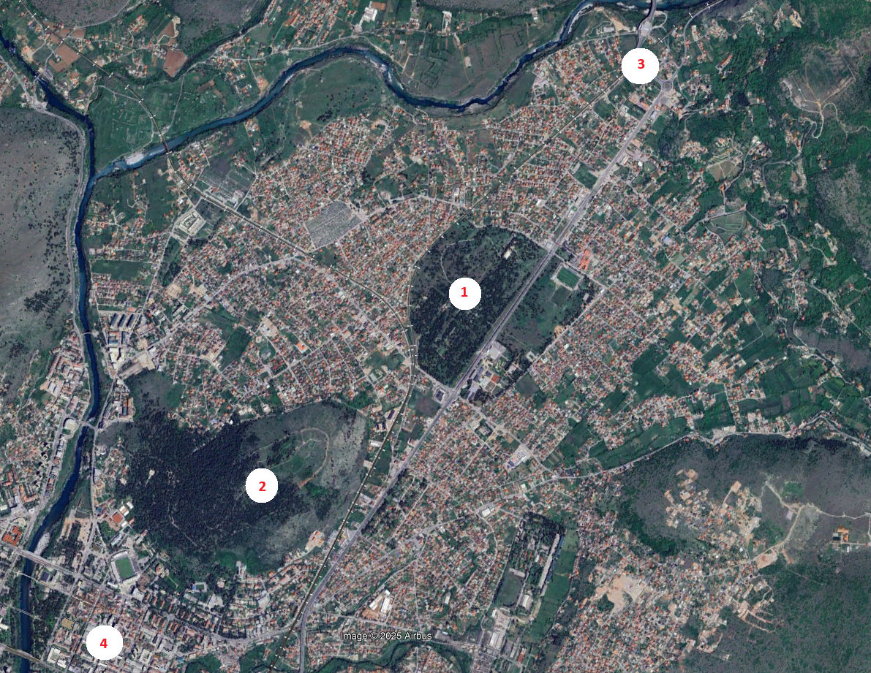

View of the broader site plan

1. Zlatica Park-Forest
2. Gorica Park-Forest, a natural monument
3. Connection to the highway to the north of Montenegro
4. Podgorica city centre

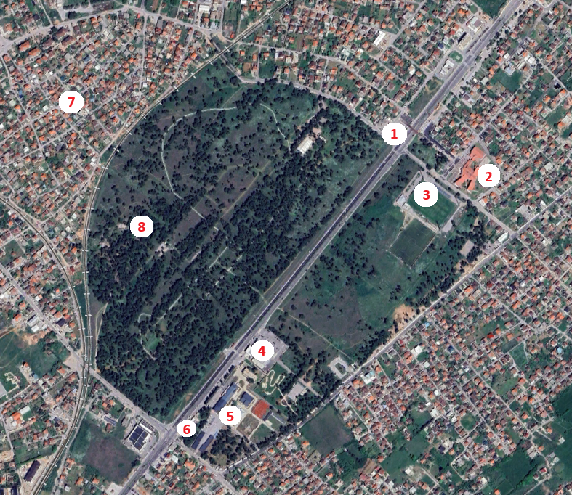
View of the immediatesite plan

1. Health Centre
2. Elementary school
3. Football stadium with auxiliary training fields of the"Kom" Football Club
4. Hypermarket
5. Training centreof the Special Police Unit and specialized police unit
6. Gas station
7. Settlement with individual housing units, separated by a railway line from the park-forest intervention area
8. "Zagorič" water source

There is a 110kV transmission line pole in the park with overhead power lines, which are also surveyed in the geodetic base. The graphic representation shows the corridor of the overhead transmission line route, within which the planning of structures is not permitted, with a width of 17.4m. Relocation of the transmission line pole is not possible.
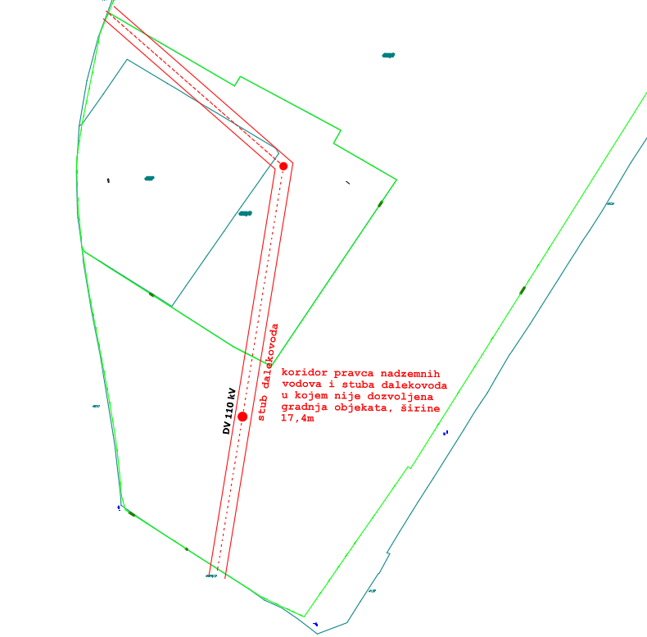
Corridor (width of 17.4 m) in which the planning of structures is not permitted

Familiarization with local natural conditions

In order to better understand the natural features, below is the information on the type and quality of soil, climatic conditions, landscape setting, and the like.
The area of ​​Podgorica is located in the climatic zone of xerothermic broadleaf-deciduous oak and hornbeam forests of the order Quercetalia pubescentis Br.-Bl. (31) 32. The primary type of vegetation, which today, unfortunately, is found only in rare fragments, was represented by Macedonian oak forests, that is, the association Quercetum trojanae montenegrinum, Bleč. et Lakušić 75. (Bl e č i ć & La k u š i ć, 1976.).

The soil is eutric brown, shallow to medium deep, skeletal, of light mechanical composition. The ecological production value of the land is low due to low soil depth (10 - 25 cm) and high permeability.

Specific features of Podgorica's climatic conditions are high summer temperatures (over 40 °C) and a strong northern wind in winter. Source of meteorological data for Podgorica:https://www.meteo.co.me/page.php?id=41

Traffic characteristics of the area

On a micro level, the subject site is served by a busy road - Vili Brant Boulevard to the east (which is one of the main exits/entrances to the city from the northern side of Podgorica), a less busy Nikola Tesla Street to the south, Branko Ćopić Street to the north, from which it is desirable to plan a vehicular connection to the park, and to the west, the park is bordered by the railway line.

The traffic solution will largely determine the manner the subject area is used. Given the designated use that excludes motor traffic, except for emergency vehicles, the participants in the competition are expected to offer a design that will include a traffic-pedestrian functional park. Along Vili Brant Boulevard, that is, the border fence of the park, there is a fire protection zone, which is not the subject of the intervention area of this competition, but it is desirable to plan the main entrance to the park as well as a parking area in this intervention area. The total parking capacity should be planned for a minimum of 115 vehicles, on the state/municipal land. The possibility ofdesigning an additional parking space is not excluded if other approaches to the park allow it.

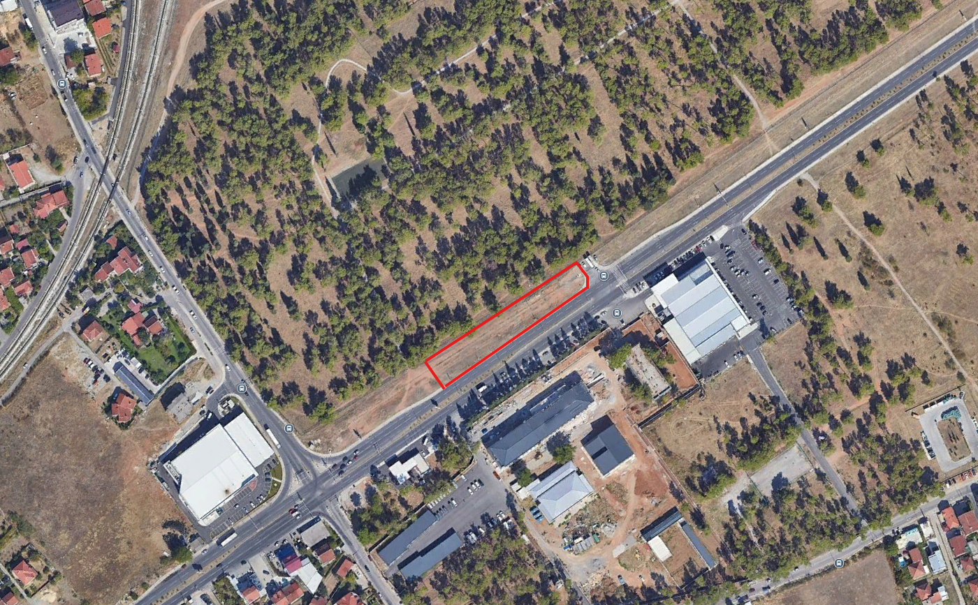
Location of the future parking area

COMPETITION BRIEF

General guidelines

The design brief defines the subject site as a multifunctional recreational park area with facilities such as a space for rest and outdoor stay, children's play, sports and recreation, and culture/education.

The zoning of the park-forest should be carried out in such a manner that the planned program facilitiesare concentrated in a few locations within the park, enabling the rest of the intervention area to be experienced as a completely natural environment. The zoning within the park should be designed separately depending on whether the area is intended for activities, rest, education/culture or similar facilities. In selectingthe facilities, take care that they enable activities that do not threaten the sustainability of the ecosystem.

Pay special attention to the development of a network of pedestrian paths that ensures the connection of all facilities, easy visibility and orientation. Position pedestrian paths through diverse, attractive parts and enable continuous circular routes through the park. Adapt the compositional design to the urban layout of the surrounding area. It is necessary to connect the network of paths with access roads, open or close the views depending on the quality of the views and the designated use of the contact zone. Conceive the compositional solution of the paths based on a study of the conditions, directions of movement of visitors, thezoning character, as well as the distribution of existing structures and vegetation. The goal is to find the most rational solutions for planning the network of park roads and paths. They should properly distribute visitors throughout the entire territory of the park, without transit movement through individual zones. Adjust the widths and slopes of the paths to accommodate the movement of all categories of users, in accordance with the Rulebook on detailed conditions and manner of adapting facilities for access and movement of persons with reduced mobility and persons with disabilities ("Official Gazette of Montenegro", No. 41/25). It should be noted that the roads and paths are both a functional and decorative element of the park, and that they are intended for park exploration as well as for activities.When planning the trails, special attention should be paid to a fire protection aspect.

Adapt the spatial layout to the designated use of the area, duration of stay, age and social structure of users, micro-climatic conditions, environmental and other values. Plan warm and durable materials for seating that ensure user comfort and safety. Adapt the materials and design to the natural surroundings, aiming for longevity and a sense of timelessness. Provide a sufficient number of waste bins at all rest areas and appropriate locations along the paths. Provide for the installation of information boards at the entrances to the park and at places within the intervention area. Plan locations for water fountains inside the park. An important aspect of the development is lighting, which should be planned in accordance with the designated use and conditions of micro locations within the park-forest. When planning lighting, apply principles that reduce negative effects on the ecosystem (low installation of lighting fixtures, directed lighting, light colour ....). All urban equipment should enable rational, innovative, functional and dynamic use of space. The design of urban furniture elements should be functional, uniform and recognizable in a modern architectural expression. For urban equipment that requires the use of electricity, consider the use of new technical and technological solutions, especially in terms of energy consumption from renewable sources.

Within the intervention area, it is possible to plan two-way bicycle paths, taking into account the safety of park visitors. If bicycle paths are defined, they can, together with fitness paths, be routed separately or alongside walking trails. Natural materials should be used for the construction of running tracks (as well as other surfaces for park facilities). The path must be soft and permeable. The current fitness trail is about 2km long, and the future conceptual designshould extend it as much as the boundaries and the facilities of the park allow. The addition of a new fitness trail is not excluded, if the future solution proves to be more favourable (more rational). The minimum width of running paths is 1.5 m to allow two people to pass each other comfortably.

We suggest considering the following facilities without limiting the scope to those listed, more precisely, the authors are free to find the most rational solution from all proposed facilities:

- Sports fields (a multi-functional field for various sports with the possibility of including a grandstand, provided that its installation/construction does not require major construction interventions in the area);
- Sports fields for other sports (suggestion: tennis, basketball, volleyball, beach volleyball, or similar);
- Climbing tower or artificial climbing wall;
- Summer stage for performances, film screenings, concerts...
- Commercial facilities (one or two cafe bars with toilets);
- Children's playgrounds (experimental playground, sensory playground and thematic playgrounds);
- Outdoor gym;
- Fitness running track
- Bicycle path
- Water surfaces that will not be deep and dominant in the space
- Fountains
- Rest zone - a quiet zone that is accompanied by its urban furniture

It is desirable for the cafe bar to be prefabricated, with the seating area arranged on a permeable surface, concreting is by no means desirable. Different types of foldable chairs, deck chairs and the use of park furniture (takeaway coffee, etc.) may be utilized.

The authors are given the possibility to design artistic installations (sculptures, installations, mosaics, murals, land art...) for the purpose of creating a special identity of the space.

The vehicular access to the site should be designed to meet the functional capacity of the park. Access for persons with reduced mobility or those using wheelchairs should be provided, as well as the required number of parking spaces in accordance with the Law and the Rulebook on detailed conditions and manner of adapting structures for access and movement of persons with reduced mobility and persons with disabilities.

New facilities for active recreation should be planned as much as possible in areas without existing trees. The landscape architecture project should provide for the revitalization of the green stock on the site, enriched with the planting of new species that should contribute to the aesthetic qualities of the area. Greening should be carried out with species that are resistant to the ecological conditions of the environment and in line with the compositional and functional requirements. It is suggested to preserve the existing trees in the peripheral part of the park as much as possible in order to maintainthe micro climate of the park. This concerns a dense unmanaged protective forest area of trees, which have grownclosely together, and due to strong winds, most of the trees are leaning and in a weakened state of vitality. When introducing new facilities and integrating existing trees, priority should be given to the preservation of groups of trees over the preservation of individual specimens. The "opening" of such clusters can often compromise the stability of the stands.
It is necessary to introduce deciduous species into the new solutions in order to transform the forest from a monoculture forest of Aleppo pine into a mixed deciduous-coniferous forest, both to enhance stability and to improve the aesthetic-landscape characteristics.
The proposed plant species must fulfil a sanitary and hygienic role (noise reduction, absorption of exhaust gases and creation of shade) and be resistant to urban and climatic conditions. The project should be developed on a site plan for terrain development. Specify the manner of protection, maintenance and irrigation of seedlings.

Specific program conditions, conclusions and recommendations

- Take into account the balance between the materials used, forms and climatic characteristics of Podgorica (high temperatures during summer/strong northern wind in winter);
- It is necessary to consider economically rationalinterventions that will be planned for the revitalization and development of the park-forest;
- The landscape-architectural solution shouldpropose facilities for uses complementary to the dominant designated use of the space, in accordance with spatial possibilities.
- In addition to the listed facilities of the sports-recreational and cultural-educational zones,the authors themselves may,through the competition brief, propose the facilities compatible with those listed.

Conditions for conducting the competition

The Competition is announced in accordance with the Rulebook on the manner and procedure for announcing and conducting a public competition for a conceptual architectural design ("Official Gazette of Montenegro", No. 19/18).
By submitting an entry, each participant accepts the terms of this competition.

Regulations and recommendations for design

When designing, it is necessary to comply with the provisions of the following regulations:
- Law on Construction of Structures ("Official Gazette of Montenegro", Nos. 19/25 and 92/25);
- Rulebook on detailed conditions and manner of adapting facilities for access and movement of persons with reduced mobility and persons with disabilities (“Official Gazette of Montenegro”, No. 41/25);

In the design process, it is also recommended to use the Manual for Planning Public Spaces in Montenegro (Ministry of Spatial Planning, Urbanism and State Property https://www.gov.me/dokumenta/480a2173-ff9e-4d3f-ad0e-1ce1320f09bd).

