**COMPETITION BRIEF**

**COMPETITION FOR THE CONCEPTUAL URBAN AND ARCHITECTURAL DESIGN FOR THE TRADE FAIR AND CONGRESS CENTRE IN PODGORICA**

**Capital City of Podgorica**

Njegoševa 13, Podgorica

Montenegro

[www.podgorica.me](http://www.podgorica.me)

CONTENTS:

**1.** **INTRODUCTION** 3

**2.** **SUBJECT AND OBJECTIVE OF THE COMPETITION** 3

**3.** **GENERAL CHARACTERISTICS OF THE LOCATION** 4

3.1. Data from spatial and planning documentation 4

3.2. Existing condition of the location 6

3.3. Familiarization with local natural conditions 8

3.4. Traffic characteristics of the location 9

**4.** **COMPETITION BRIEF** 9

4.1. General guidelines 9

4.2. Specific programme conditions, conclusions and recommendations 12

4.2.1. Conditions for conducting the Competition 12

4.2.2. Regulations and recommendations for design 12

# **INTRODUCTION**

The Mayor of the Capital City of Podgorica issued a Decision on announcement of a Competition for the conceptual urban and architectural design for the trade fair and congress centre in Podgorica No.01-018/25-2562 of 15 April 2025.

The legal basis for the adoption of the Decision is contained in the provisions of Article 15, paragraphs 1 and 4 of the Law on Construction of Structures ("Official Gazette of Montenegro", No. 19/25), Article 6 of the Rulebook on the manner and procedure for announcing and conducting a public competition for a conceptual architectural design ("Official Gazette of Montenegro", No. 19/18, 2/24 and 8/24), as well as Article 100, paragraph 1, item 20 of the Statute of the Capital City ("Official Gazette of Montenegro – m.r., No. 8/19, 20/21 and 49/22).

The competition for a conceptual design is announced and conducted in accordance with the Rulebook on the manner and procedure for announcing and conducting a public competition for a conceptual architectural design ("Official Gazette of Montenegro", No. 19/18, 2/24 and 8/24).

The subject site is located within the scope of the current DUP "DUP Agri-industrial Zone" ("Official Gazette of Montenegro - m.r.", No. 57/17) and is currently undeveloped.

# **SUBJECT AND OBJECTIVE OF THE COMPETITION**

The subject competition is the result of the need to obtain a facility through a trade fair and congress centre that will be a generator of the event industry, not only in the Capital City of Podgorica, but also at the national level, with the aim of raising the socio-economic quality of life of all residents. The event industry has a multiple impact, both on the economy and on the characteristics of the environment, but also on the life and culture of the community, either directly or indirectly. As tourism is one of the leading industries in Montenegro, the future centre is of particular importance for the further growth of the trade fair and congress tourism, resulting not only in a greater turnover, but also better marketing for the city.

It creates the possibility for Montenegro and Podgorica to integrate into prestigious international trade fair and congress associations. On the other hand, trade fairs, as a strong impetus for trade, are one of the attributes of the market economy.

The subject of the competition is the development of a conceptual urban and architectural design for a trade fair and congress centre in Podgorica. The effects of organizing trade fair events, congress activities, and special events are of immense importance for generating tourist demand and economic effects. The common term "business events" refers to **trade fairs, conferences, conventions, congresses and meetings,** which have direct and indirect effects on the socio-economic development of the city. The additional flexibility of the trade fair halls will provide the opportunity for organizing related events/happenings that bring together a larger number of people, such as **concerts, musical and stage performances, festivals, carnivals, and sports events** or similar.With the existence of the trade fair and congress centre, the Capital City, as well as the state, will develop "event production" which should result in a better national economy. In a professional sense, the subject structure should provide a modern architectural and landscape oasis, by combining its volume with architectural subtlety on the one hand and landscaping on the other. At the same time, the structure must integrate sustainable principles, including efficient energy use and the use of environmentally friendly materials. Attention should be paid to passive elements of sustainable construction (insolation, shading, orientation, etc.). The function planned for "event production" with the architectural expression of the trade fair and congress centre should contribute to the improvement of the image, identity and character of the city.

Conceptual designs in the competition are expected to provide:

- **Flexibility of space** – the focus is on spaces being designed as "machines" that allow for easy transformation into several configurations in a short time and for multiple organizational needs;

- **Distinctive design** – aligned with the local context in the domain of rational construction;

**- Focus on energy efficiency and sustainability of the complex** - Integration of sustainable principles into the project, including efficient energy use and the use of environmentally friendly materials;

# **GENERAL CHARACTERISTICS OF THE LOCATION**

The boundary of the area covered by the competition is given on the geodetic survey map in the competition material. **The area covered by the competition is 28,884m2 (2.88 ha),** and it includes cadastral plots no. 7944/2, 7904/34, 7944/4, 7951/3 and 7904/35 of CM Podgorica III, which include urban plots No. 3.1, 3.2, 3.3 and 3.4, Block 3, Zone II, DUP "Agri-industrial Zone". The Decision on determining the location was adopted by the Assembly of the Capital City of Podgorica No. 02-016/24-252 of 29 March 2024.

## Data from spatial and planning documentation

The subject site is located within the DUP* "Agri-industrial Zone" of 2017, which states:

"As this is an area with significant potential for development of a business zone and excellent transport connections, it is a part of the city area intended primarily for industrial production in which a certain number of plants have been built. Industrial plants often have common infrastructure (railways, roads, gas pipelines, electrical lines, water supply, sewerage, telecommunications, etc.). Apart from the predominant purpose (industry and production) and compatible with that purpose, the following may be located: structures and facilities for business, commercial and service activities; parking lots and garages for accommodating vehicles of users (employees and visitors).

If the UT conditions are issued for several urban plots that will function as a single location, the dimensions and mutual relationships of individual structures and groupings need to be determined through development of a conceptual design for the location."

According to the planning document, it is allowed to design a gross area under structures of 8,928m2, **a gross construction area of ​​13,392m2**, and number of floorsGF+4 for the location, which includes four urban plots. It is necessary to provide a minimum of 38% of green areas.

**The plan allows the construction of underground floors on all plots (intended for service areas necessary for the functioning of the underground garage, as well as the technical systems of the structure) which are not calculated in the gross construction area.** The area under the underground floors may be larger than the area of the ground floor, but the coverage of the plot by underground floors may not exceed 60% of its area.

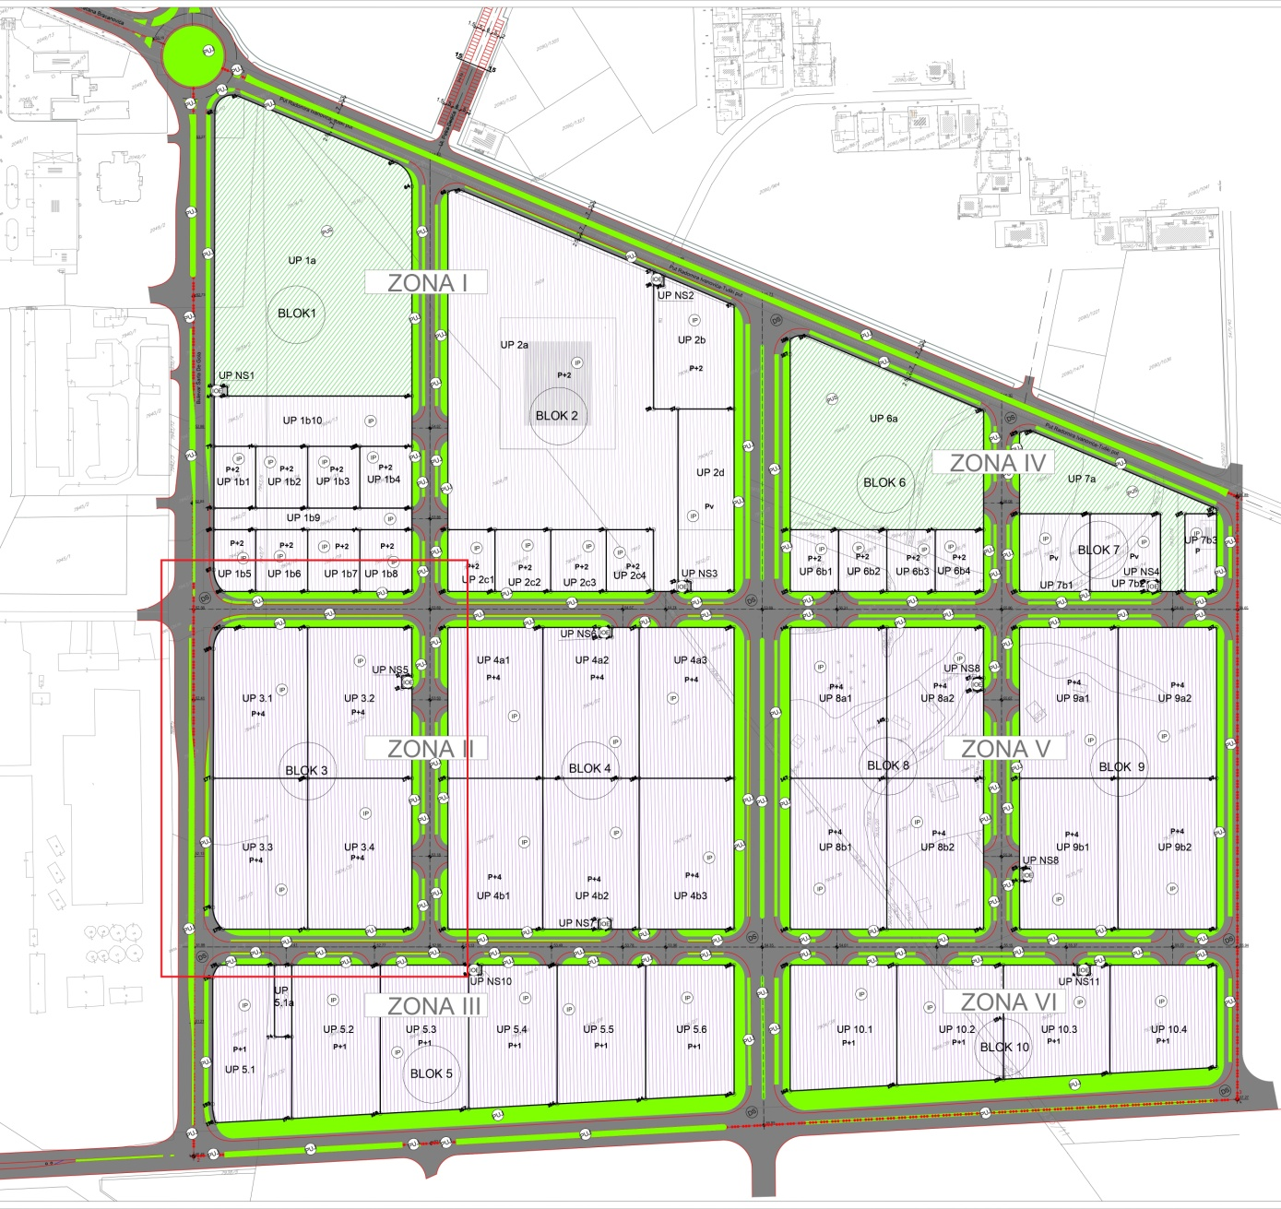

*.View of the location in the DUP, appendix - Detailed land use*

*DUP* – Detailed Urban Plan*



Tabular extract from the DUP "Agri-industrial Zone" for the four urban plots that constitute the subject location

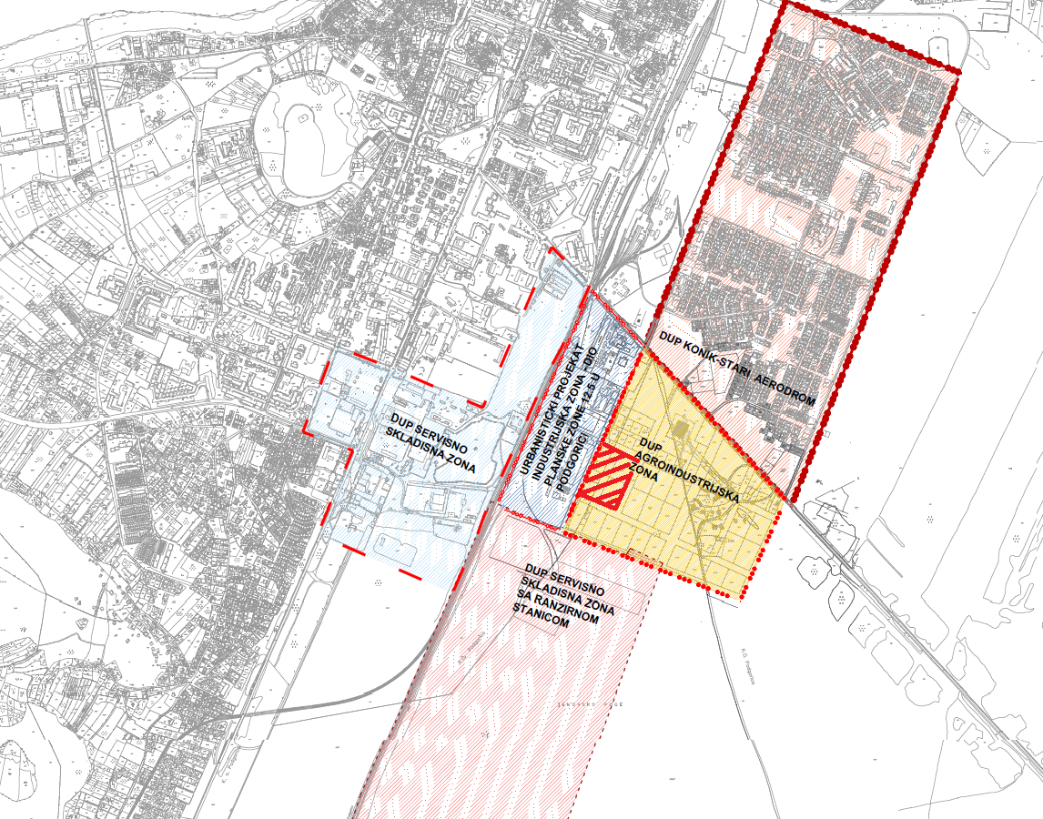

*View of contact DUPs*

## Existing condition of the location

The location of28,884m2planned for the future trade fair and congress centre is positioned outside the densely built-up city area, towards the peripherywhich has good transport connections. On the macro level, the route of the cross-border road to Albania runs on the eastern side of the location, Ćemovsko Field with a small proportion of built-up area is on the southern side, and the city structure with a larger proportion of built-up area ison the northern and western sides. On the micro level, the location is bordered on the north by 13 JulyPark, on the west by the busy “Charles de Gaulle” boulevard that separates it from an industrial wine production plant, on the south by the Tobacco Plant, and on the west by the undeveloped area of ​​Ćemovsko Field. The location itself planned for construction is mostly flat, with a not-too-high percentage of tall vegetation, mostly in the northern part, which, if the design solution allows, needs to be preserved and made to enrich the future landscape and ground floor design of the trade fair and congress centre.

The location is on the periphery of the city and has good connections to the airport, railway and road traffic. Moreover, the area covered by the competition is not located within the traditionally-inherited urban context, so in this regard, the design of an innovative zone is allowed, which needs toobserve the existing infrastructure and landscape conditions.

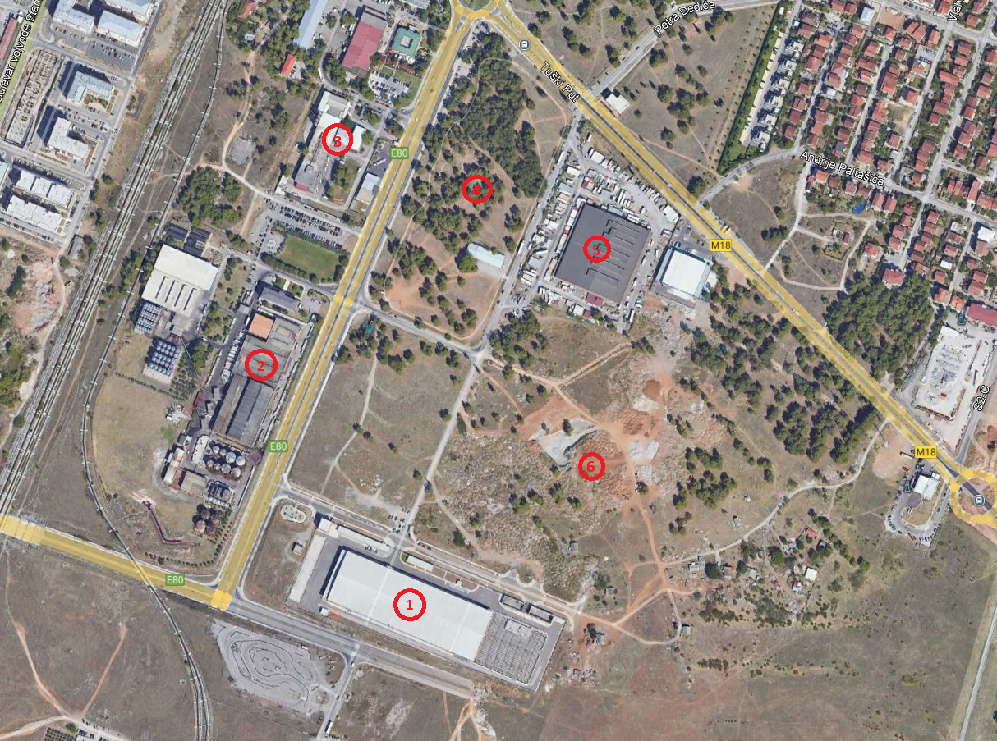

View of contact zone

1. Tobacco Plant

2. Industrial plant – wine production (“Agrokombinat 13 jul”)

3. Restaurant “13 Jul”

4. Sports and recreational zone “13 jul”

5. Distribution centre – Green market

6. Undeveloped area

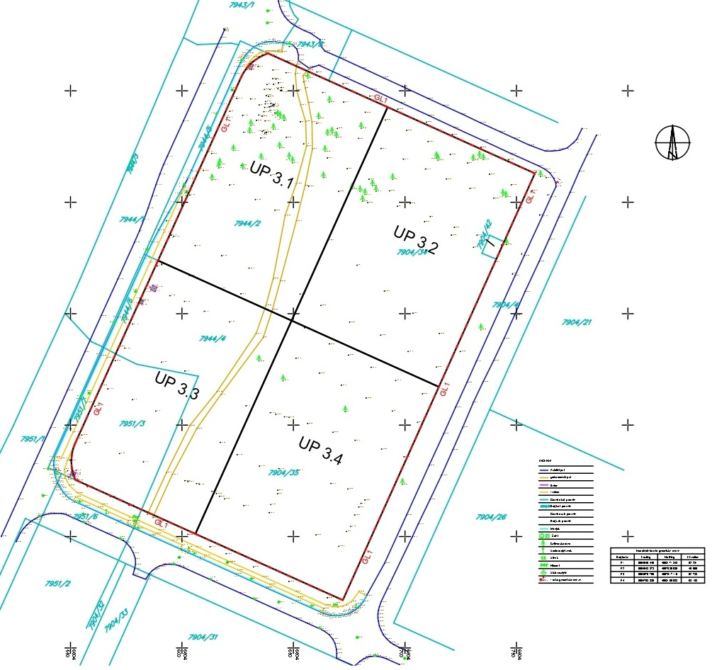

Geodetic base showing urban plots and building lines

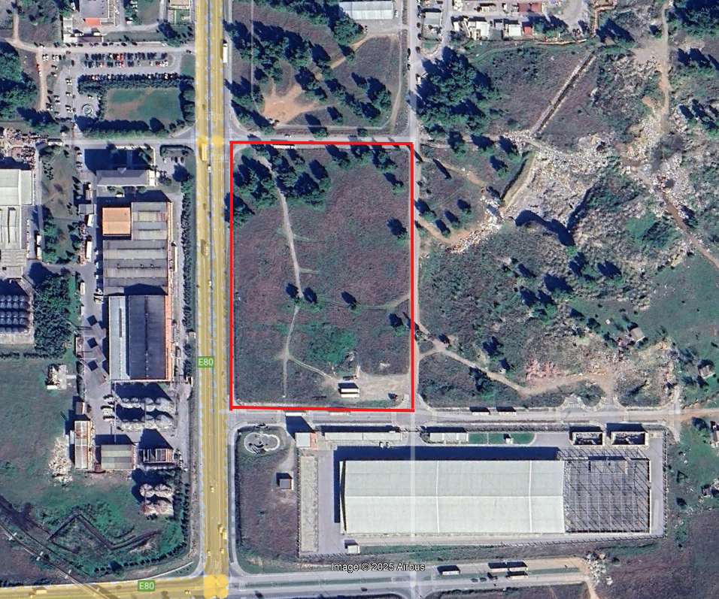

Area covered by the location

## Familiarization with local natural conditions

In order to better understand the natural features, below is the information on the type and quality of soil, climatic conditions, landscape, and the like.

In morphological terms, it is a flat terrain with a minimal slope (less than 50). The category of bound and semi-bound lithological structures includes: shales, claystones, marls, sandstones, etc. These terrains have good bearing capacity. The pedological characteristics of the Zeta Plain and Ćemovsko Field are as follows: in geological terms, the plain is composed of alluvial-diluvial deposits, most often brown soils on gravel and conglomerate. The groundwater level ranges from 4 m in relation to the upper surface of the terrain.

The impact of the facilities of the contact zones from the aspect of air pollution is not great. "Agrokombinat 13.jul" is intended for the food industry and is not an environmental polluter.

The territory of the subject DUP is mostly empty land, except for parts that are under forest plantations (Aleppo pine and cypress).

The subject location, but also a larger areacovered by the DUP Agri-industrial zone was afforested in 1954 with Aleppo pine seedlings with a small share of cypress. Due to the unfavourable environmental conditions of the poor skeletal soil and intense summer heat, the trees had little growth, and do not give the impression of a strong 60-year-old plantation. The decorative-aesthetic and health value of the trees is average, but with the application of the necessary measures, the plantations should be preserved because they managed to survive without the application of the necessary care measures and contribute to the creation of favourable microclimatic conditions. Other areas are mostly bare (without high vegetation). The ecological system is particularly improved by the plantation of the forest complex of Aleppo pine and cypress in the area of ​​the DUP Agri-industrial Zone. The greenery of the subject complex forms "a connection between the urban/city green areas and non-urban empty areas. Together with the neighbouring block greenery of the settlement "Konik - Stari aerodrom", the subject area forms a high-quality whole of the city's forest areas.

As regards natural conditions, this area has a number of advantages for construction and urbanization.Flat terrain, a favourable groundwater level, as well as good stability of the terrain are characteristics that favour construction. Specific features of Podgorica's climate are high temperatures in summer (over 40 °C) and strong north wind in the winter. The source of meteorological data for Podgorica:<https://www.meteo.co.me/page.php?id=41>

## Traffic characteristics of the location

As regards the trade fair industry, in which participation in events implies the display of exhibits as well as an abundance of advertising and promotional material, the advantage of the location is a good road and railway infrastructure. Considering the macro plan, the subject location is served by two high-frequency roads, namely, the already built Podgorica - Tuzi road on the north-eastern side and Charles de Gaulle Boulevard (which borders the "Agri-industrial Zone" complex) on the western side, and on the northern, eastern and southern sides, considering the micro plan, there are roads of less intensive frequency, from which it is desirable to plan a vehicular access to the structure.

# **COMPETITION BRIEF**

## General guidelines

1. Entrance zone

Area: approx. net 2,600m2

Capacity: approx. 2,800 people

The entrance zone is intended for the communication and connection of the planned facilities in the structure and at the same time it carries the potential for extension of the exhibition space and organization of special events. Therefore, it is necessary to consider it as a valuable space, the so-called "hub" of the structure that has the capacity to serve several events that would be organized at the same time. It is planned to have a windshield, a foyer (min. 0.9m2 per participant) - as a "connecting tissue" for rich free activities, clear guidelines for communication, as well as several lobbies that are directly connected to individual halls. Then there is a ticket office, a reception desk, a cloakroom (area about 0.1m2 per participant), a cafeteria with a small pantry for storing food/drinks, a doorman’s booth, communication, and a sanitary block.

1. Exhibition zone – multipurpose hall

Area: approx. 5,000m²

In a multipurpose hall, it is possible to organize trade fairs, conferences, conventions, concerts, musical and stage performances, sports events, festivals, weddings, carnivals or similar. The quality of the space should be reflected in the possibility of its transformation, more precisely, the possibility that the exhibition space can be divided into several smaller ones. At the same time, it is necessary to carefully analyse the volume of the exhibition space, its height, acoustics, as well as its position in relation to the entire assembly and the external space. The multifunctional exhibition hall should have the natural lighting. Plan a service entrance to the exhibition hall, a cafeteria area, and a sanitary block. Depending on the type of event, the possibility of telescopic stands is not excluded.

1. Conference zone

Area: approx. 2,500m2

Conventions, conferences, weddings, working meetings, seminars or the like can be organized in the conference zone. Plan a congress hall for 1200 participants, which, depending on the needs of the event, can be divided into several smaller ones. Within the same space, the number of users will vary depending on the spatial organization and the way they are used: classroom style/theatre style/banquet style/U-shape style/reception style). Additionally, plan two independent smaller conference halls for approximately 200 participants. Plan space for conference equipment, interpretation and other services, chair storage, foyer and lobby described in the entrance area, with an accompanying cafeteria, and sanitary block.

1. Administrativezone

Area: approx. 330m2

Number of people in the administrative zone: approx. 15-20

Clean communication, avoiding exhibition communication

Facilities: Offices (organizers, technical team, security team, support staff), communication, office and archive, working rooms and the room for holding conferences and meetings, sanitary rooms (technical, service and storage areas can be separate or as common areas for the entire structure, depending on the design solution).

1. Economic zone (restaurant kitchen and storage zone)

Area: approx. 1,000m2

(if part of the space of the conference hall or multipurpose hall is used for the organization of wedding celebrations, up to 500 people)

The subject zone includes an economic yard for kitchen needs, congress centre service, kitchen block, workshops, decoration and equipment depots, etc. The kitchen should be connected to the multi-purpose hall but also to the conference area where kitchen service is necessary (banquet, tastings, exhibitions, working lunch, breakfast, dinner, etc.)

1. Commercial zone - Business premises(s)

Area: approx. 450 m2

On the ground floor of the structure, in the function of the commercial use of ​​the structure, plan a business premise that will be subsequently converted into its intended use depending on the needs.

1. Parking zone

Capacity: approx. 500 PPs

Facilities: Parking for cars in the garage (depending on the overall design solution, partial parking on the ground floor is possible)

1. Service zone

Space for technical systems of the structure

1. Ground floor arrangement zone (open exhibition space, if necessary)

Intended use: The arrangement of the remaining part of the plot should ensure a pleasant stay for visitors as well as social interaction, and when necessary, serve as an open-air exhibition space. The ground floor should have the potential for the extension of the outdoor exhibition space, which would be connected to the multi-purpose hall. The possibility of subsequently setting up temporary pavilions on the ground floor, depending on the exhibition/trade fair setting, is not excluded. When talking about external arrangement, it is necessary to take into account the context, and the knowledge of extremely unfavourable climatic conditions - great heat and strong wind, so it is necessary to offer an adequate solution to the climatic inputs of the location.

|  |  |  |
| --- | --- | --- |
| Spatial component | Net m2 | Comments |
| Entrance zone | 2,600m2/2,800 people |  |
| Exhibition zone - Multipurpose hall | 5,000m2 |  |
| Conference zone | 2,500m2 |  |
| Administrative zone | 330m2 |  |
| Economic zone (Restaurant kitchen and Storage zone) | 1,000m2 |  |
| Commercial zone - business premises | 450 m2 |  |
| Parking | 500 PPs | The underground garage is not calculated in GCA |
| Service zone - spaces for technical systems of the structure |  | Desirable in the underground floor - not calculated in GCA |
| Non-allocated areas (external walls and structure, communications, staircase and elevator core, installation shafts, etc.) | 1,500 m2 |  |

***The designed areas of the zones within the structure are approximate and will be reviewed in the competition design. However, the urban planning parameters set by the plan (area under the facilities and gross construction area) must not be changed.***

## Specific programme conditions, conclusions and recommendations

* Depending on the design solution, the structure may be integral, or in several levels, parts - pavilions or similar. Take into account the balance between the available natural lighting and the climatic characteristics of Podgorica (high temperatures during summer/strong north wind in the winter);
* It is necessary to take into account the cost-effective use of materials that will be planned for the construction and appearance of the structure (concrete, steel, wood, etc.), as well as sustainable principles, including efficient use of energy;
* Treat urban planning, structure and landscaping in an integrated manner, sincethe complex gains an added value by interweaving open and closed exhibition spaces;
* The design solution is expected to define a clear vehicularaccess to the structure (it is preferable to plan it from roads with a less intensive frequency), pedestrian and economic access.

## Conditions for conducting the Competition

The Competition is announced in accordance with the Rulebook on the manner and procedure for announcing and conducting a public competition for a conceptual architectural solution ("Official Gazette of Montenegro", No. 19/18).

By submitting the entry, each participant accepts the propositions of this Competition.

## Regulations and recommendations for design

When designing, it is necessary to comply with the provisions of the following regulations:

* Law on Construction of Structures ("Official Gazette of Montenegro", No. 19/25);
* Rulebook on detailed conditions and manner of adjusting facilities for access and movement of persons with reduced mobility and persons with disabilities (“Official Gazette of Montenegro”, No. 48/13 and 44/15);
* Rulebook on the conditions for the preparation of technical documentation for buildings in which office operations are performed ("Official Gazette of Montenegro", No. 89/23) as well as other regulations governing the construction of structures.

In the design process, it is also recommended to use the *Manual for Planning Public Spaces in Montenegro* (Ministry of Spatial Planning, Urbanism and State Property https://www.gov.me/dokumenta/480a2173-ff9e-4d3f-ad0e-1ce1320f09bd).